Institute of Technology, UW Tacoma

TCES 455 Devices and Controls

Final Exam

**Instructor**: Jie Sheng

**Date**: Dec. 11th, 2014

**Time**: 10:00am – 5:00pm

**Instructions**:

This is a take-home exam. That means you neither give nor receive help or advice regarding this exam from anyone other than the instructor. Anyone found to be giving or receiving help will be given a score of ZERO. You are on your honor.

Late submission will not be graded.

Zip together the following items and turn them in on Canvas:

* There are 10 questions in this exam, and the total is 100 points. You will fill in the spaces provided in this document.
* MATLAB allows you to export a plot as a jpeg file. Whenever plots are required (using either MATLAB or SIMULINK), please use jpeg files.
* A photograph of your signature on the statement below.

Make sure all of your materials are in the zip file. It’s up to you to make sure you turn in the entirety of your exam.

**I neither gave nor received help from any individual or group in person or online other than the instructor of this course. And I have read and understand all of the instructions on this page.**

Signature__signature below______________ Date__12/11/14_____



In the water level control project, we first studied an idea water tank shown in Figure 1,

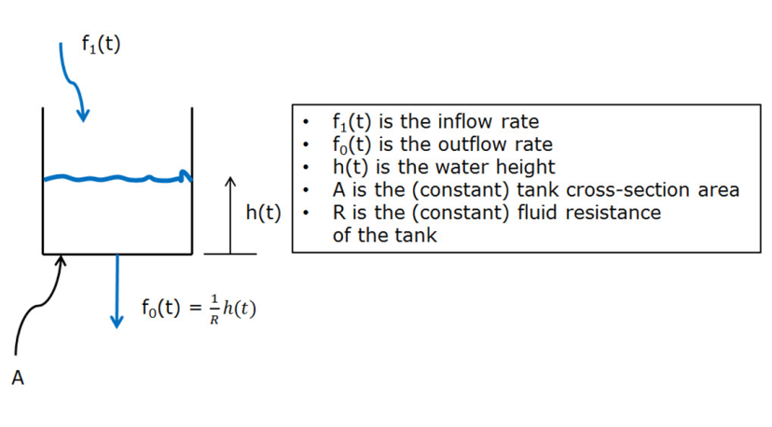

Figure 1: An ideal water tank

We found the governing differential equation is as follows,

$$A\frac{dh(t)}{dt}+\frac{1}{R}h\left(t\right)=f_{1}(t)$$

which is equivalent to the transfer function $T\left(s\right)=\frac{H\left(s\right)}{F_{1}\left(s\right)}= \frac{\frac{1}{A}}{s+\frac{1}{RA}}$ shown in Figure 2.

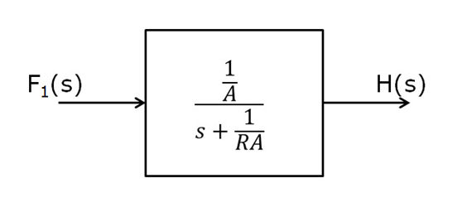

Figure 2. Ideal Water Tank

The closed-loop water level control system looks like Figure 3.

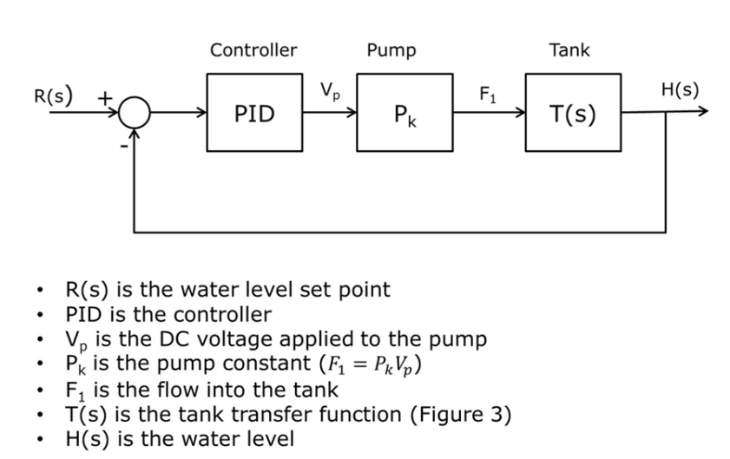

Figure 3. Closed-loop water level control system

Suppose we have measured the inside diameter of the tank and it is 60mm. The height of the water when the tank is full is 14 cm, measured from the bottom of the tank.

Q1: (5%) What is the area, *A*, of the tank cross-section (specify units)?

___28.27433 cm^2_________________________________________________

Q2: (5%) What is the volume of water in the tank when it is full (specify units)?

___395.84 cm^3___________________________________________________

Starting with a full tank, when we open the valve at the bottom, it takes about 8 sec. for the tank to empty.

Q3: (15%) Use MATLAB to find an approximate value for *1/AR*. Attach the MATLAB code to verify the value of *1/AR* satisfying the description above.

___1/AR = 0.3298823 per sec________________

Q4: (10%) According to your results in previous steps, what is $T\left(s\right)=\frac{H\left(s\right)}{F_{1}\left(s\right)}= \frac{\frac{1}{A}}{s+\frac{1}{RA}}$?

_____0.035367 / (s + 0.32988)__________________________________________

We have found that at 9V the pump can fill the tank in 7 seconds.

Q5: (10%) What is the pump constant, $P_{k}$ (specify units)?

______6.2831844 cm^3 / Volt*sec______________________________

Once we finish the modeling steps, we are going to use MATLAB to design PID controllers by simulating a unit step function driving the closed loop system shown in Figure 3. Suppose the PID controller has the format $K_{p}+\frac{K_{i}}{s}+K_{d}s$. Our design goals include:

* Rapid rise time
* Small overshoot is OK (up to 5% to 10% overshoot is acceptable)
* Water height tracks set point one for one (i.e., the steady state response to a unit step function is 1.0).

Q6: (15%) Start with $K_{p}=1$, $K_{i}=0$, and $K_{d}=0$ to get a feel for a simple controller. Tuning them based on your understanding of the three PID terms, find the right values of $K_{p}$, $K_{i}$, and $K_{d}$ that meet this goal. Verify your results by simulation results, i.e., plots (representing the unit step response of water level) generated by either MATLAB codes or SIMULINK. Note that MATLAB allows you to export a plot as a jpeg file. In addition, submit your MATLAB codes/scripts, or SIMULINK file.

__Using the Nichols-Zeigler method, I found K_p to be equal to 5.4, K_i equals 2.7 and K_d equals 2.7.__

Since we are curious what voltages are required to implement our control system, redraw the closed-loop in Figure 3 so that its input is the set point $R\left(s\right)$, while the output is the calculated control voltage $V_{p}(s)$ to be applied to the pump.

Q7: (10%) Submit your SIMULINK file showing the redrawn closed-loop system with input $R\left(s\right)$ and output $V_{p}(s)$. Plot $V_{p}$ when a unit step function is applied to the system. Include your plot in your final exam submission. Note that MATLAB allows you to export a plot as a jpeg file. Is the steady-state behavior of the pump zero? If not, explain your observation.

__The steady-state behavior of the pump is not zero. The value bounces between 1.5 and about 1.75. This means that the pump is constantly putting water in until the inflow rate matches the outflow rate__

Q8: (10%) Continuing Q7, plot $V_{p}$ when the water level is set at 10cm, i.e., a step function with final value of 10 is applied to the system. Include your plot in your final exam submission. Note that MATLAB allows you to export a plot as a jpeg file. What’s the steady-state behavior of the pump? Does it make sense, i.e., can the device in the real world work as you simulated?

__The steady state behavior of the pump is around 15-17 Volts. This doesn't make sense because it should be beyond the operating voltage of the pump, so the device would not work in the real world as was simulated.__

Q9: (10%) Continuing Q8, to protect the real device, we have to put constraint on the control voltage to be applied to the pump. In SIMULINK, there is a saturation block in the library discontinuities. Add this block right after the PID controller, and suppose the pump can only work in the range 0-9 volts. Assume the PID calculated voltage is $V_{p}$, the bounded voltage is $V$. Plot $V_{p}$, $V$ and the real water level, when the expected water level is 10cm, i.e., a step function with final value of 10 is applied to the system. Include your plots in your final exam submission. Note that MATLAB allows you to export a plot as a jpeg file. Can the real water level be controlled to arrive 10cm? Yes or No, explain your answer. If your answer is No, what would be your solution?

__The real water level will never arrive to 10cm. It will only rise up to about 6cm because the input voltage is capped at 9. One solution would be to get a bigger pump that could take more input voltage. Another solution, if you're more worried about the height and not the volume of water in the tank, then you could get a tank that has a smaller cross-sectional area. Another solution would be to slightly close the valve, which would increase the fluid resistance.__

Q10: (10%) Back to the closed-loop system in Figure 3, we now want to plot the error (the error between the water level set point and the real water level) term in response to a unit step input by either MATLAB codes or SIMULINK. Note that MATLAB allows you to export a plot as a jpeg file. Include your plot in your final exam submission. In addition, submit your MATLAB codes/scripts, or SIMULINK file. Is this the behavior we want? Explain.

__Yes, this is the behavior we want. Initially, the error is high because the water tank starts at a value of zero and then increases. The error undershoots a little because the real water level overshoots. The steady state error is zero though because eventually the real water level reaches the water level that we set, and this is what we want.__